Fraud Detection Analysis
Objective: Build a model that detects anomaly and irregular patterns in customer transactions for a fintech firm.
Tool Stack: Initial Credit card Data from Kaggle, Python
The goal of this project is to design and simulate an end-to-end fraud detection system that mimics real-world fintech pipelines, including continuous data generation, storage, feature engineering, model training, and real-time fraud decisioning.
Introduction
I downloaded the data I would be using for this project from Kaggle.com, This data contains data for a bank whose columns have been totally anonymized for the purpose of modeling and re-modeling. Moving forward I will do my own personal wrangling on this dataset and possibly further continuous data entry process to have a better touch of live data update and fraud detection tracking. Stay with me!
Data Wrangling
How does the data look?
Rows = 284806
Columns = 31
Null Values = 0
Duplicates = 1081
Data types = Float, Integer
Values for the Column Class = 0 for false, 1 for True
After dropping duplicates we now have a clean dataset, I will go ahead to create a copy I would be doing some wrangling on
Creating a proper Fintech Schema
- I added two new columns, transaction_id and customer_id
- I reordered the columns
- I confirmed the current fraud ratio and it appeared imbalanced which is normal
Now we have a dataset ready for further modeling and feature engineering
Fraud rate in the dataset currently sits at 0.17% which is realistic in real world application, although highly imbalanced. So evaluation focuses on detecting fraud cases rather than overall accuracy.
Exploratory Data Analysis
Now I have cleaned and shaped my dataset to look like actual fintech data with unique IDs, I would move forward to exploring patterns in the dataset before modeling and feature engineering.
Let’s have a look at our current dataset columns
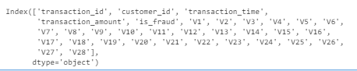
My observations.
- Transaction amount comparison (Fraud vs legit):
- Both are extremely right skewed
- Fraud size is tiny compared to legit
- Legit goes up to ~25,000
- Fraud mostly stays below ~2000
- Fraud distribution is more compact
- Legit distribution is wider and more volatile

- Time based patterns:
- Fraud attempts are disproportionately concentrated in early morning hours (2 AM – 4 AM) where fraud rates are up to 10 to 15x higher than daytime levels
- Mini spikes on fraud cases also occur around 5 am and 11 am

- Transaction Amount vs Fraud:
- From the boxplot using the median line fraud transactions seem to be more concentrated and higher
- The fraud boxplot looks more stretched (A mix of both small and very large transactions)
- Legit transactions have what may look like outliers but could be very large transaction amounts
- Both box plots overlap

- Correlation:
Strong Negatives.
V17 → -0.313
V14 → -0.293
V12 → -0.251
V10 → -0.207
V16 → -0.187
V3 → -0.182
V7 → -0.172
These columns although anonymized helps the model signal low probability of fraud.
Strong Positives.
V11 → +0.149
V4 → +0.129
V2 → +0.085
These indicates higher probability of fraud
Weak Correlations.
transaction_amount → 0.0057
transaction_hour → -0.0167
These are weak indicators to correlate with fraud, using them alone will not be the most ideal.
Feature Engineering
Now we are moving to more elaborate process of observing things that has really happened throughout the given dataset.
We are creating new columns.
- Transaction Count per Customer (txn_count_per_user)
Counts how many transactions a user has made before the current transaction, capturing user activity level.
- Average Transaction Amount per Customer (avg_amount_per_user)
Calculates the average transaction amount a user has made up to this point, providing a baseline for normal spending behavior.
- Deviation from User Behavior (amount_deviation)
Measures the difference between the current transaction and the user’s historical average. Large deviations may indicate anomalous transactions.
- Transaction Frequency (txn_per_hour)
Captures the speed of transactions per user (e.g. if a user makes a transaction every 5 seconds it gives the probability of how many transactions, they are likely to make in the next hour). Rapid transactions are often associated with fraud.
- Transaction Hour (transaction_hour)
Extracts the hour of the day. Fraud patterns observed during early morning hours are highlighted.
- High-Risk Hour Flag (high_risk_hour)
Flags transactions occurring during periods with historically high fraud activity (2–4 AM).
- Log-Transformed Amount (log_amount)
Reduces skew in transaction amounts, making models more stable.
- Relative Amount (relative_amount)
Compares the current transaction to the user’s historical average, highlighting unusually large or small transactions.
Note on V1–V28 Features:
The anonymized PCA features (V1–V28) do not have direct real-world meaning. Their value lies in improving model predictions, and we treat them as black-box inputs without interpreting them as specific transaction behaviors.
Fraud Detection Model
After creating the new featured columns, we will be training our detection model.
Some key terms to note before we dive into analyzing the model
- True Negatives: Shows how many transactions the model finds legit.
- True Positives: Shows how many transactions the model finds fraudulent.
- False Negatives: Shows how many fraudulent cases the model did not flag.
- False Positives: Shows how many legit transactions were flagged as fraud.
- Precision: Shows how precise the model is scaling is from 0 to 1.00
- Recall: Shows how good the model is at catching fraud cases
- F1-score: This is the balance between precision and recall
- Support: This is the number of actual occurrences of both fraud and non-fraud cases in the model.
- Accuracy: Describes how many predictions the model got overall. For a fraud detection model this is not useful because it will always get a high accuracy for non-fraud cases.
Logistic Regression: I used Logistic Regression with
class_weight='balanced' to handle class imbalance
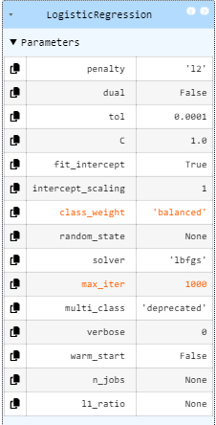
Confusion Matrix:
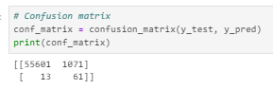
Total Fraud transactions = 74
Total Legit transactions = 56672
- True Negatives = 55601
- True Positives: 61
- False Negatives: 13
- False Positives: 1,071

Key Metrics (Fraud Class)
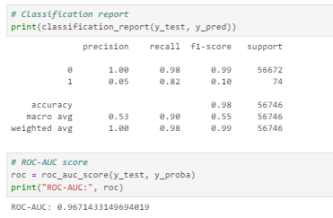
- Recall: 0.82
Model successfully detects 82% of fraudulent transactions
- Precision: 0.05
High number of false positives
- ROC-AUC: 0.967
Strong ability to distinguish fraud vs legitimate transactions
This baseline model demonstrates strong fraud detection capability but requires optimization to reduce false positives before deployment in a real-world system.
** It is key to note that when training the model, I focused more on recall than accuracy because missing fraud leads to direct financial loss, while false positives mainly affect user experience. The bottom line: High recall with acceptable precision

Optimizing the current model for better precision to avoid false alarms.
I will go ahead to increase the threshold and observe changes in the model.
The default threshold: 0.5
New threshold: 0.9
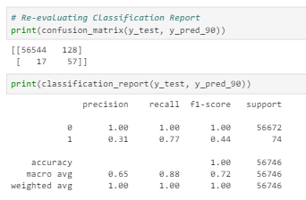
- True Negatives: 56544
- True Positives: 57
- False Negatives: 17
- False Positives: 57
- Recall: 0.77
Slightly lower detectability than the first model
- Precision: 0.31
Higher precision with much lesser number of false positives
The model acts smarter however we can still test other thresholds to see if the precision and recall will increase further.
I ran a loop with other thresholds like 0.3, 0.5(default), 0.7 and 0.9
Key Findings:
- Lower thresholds (0.3–0.5):
  - High recall
  - Extremely low precision (many false positives)
- Higher thresholds (0.9):
  - Significantly improved precision
  - Slight reduction in recall
- Optimal Balance (0.7):
  - Maintains high recall (~82%)
  - Improves precision nearly 3x over baseline
A threshold of 0.7 was selected as it offers the best trade-off between fraud detection and minimizing false positives.
With the threshold 0.7 being our best for the model I will still go ahead to enhance the model as 82% recall still misses out on some fraud case and still flags legit transactions as fraud.

Introducing a more robust model called Random Forest Classifier
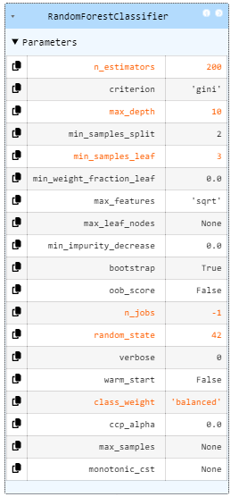
By introducing this model, I got a more precise detection as the false alarms went down significantly to just 4 false. Although recall slightly dropped to 74%
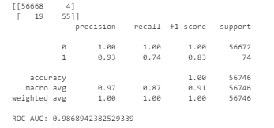

I will go further to test other thresholds like I did in the previous model.
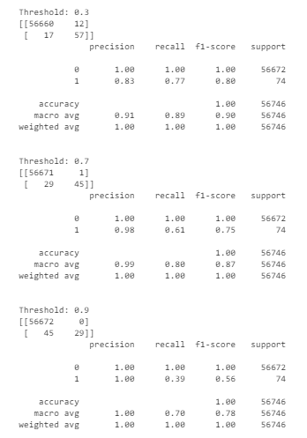
After evaluating multiple models and thresholds:
- Random Forest significantly outperformed Logistic Regression
- Achieved high precision and strong recall
Final Configuration:
- Model: Random Forest
- Threshold: 0.5
Performance:
- Precision (fraud): 0.93
- Recall (fraud): 0.74
This configuration provides an optimal balance between detecting fraudulent transactions and minimizing false positives, making it suitable for real-world deployment.
I went ahead to save the RFC model. Moving forward I would simulate my own data for real world use cases and deploy a model that would be put to work exactly how fraud detection models work in real fintech scenarios.
Simulating a realistic system
Customer Behavior Tracking: To simulate realistic fraud detection, a lightweight in-memory tracking system will be implemented using dictionaries to store historical customer activity.
Components
- customer_last_time
Stores the timestamp of the most recent transaction per customer.
Used to compute time gaps between transactions (time_diff).
- customer_txn_count
Tracks the total number of transactions per customer.
Used to estimate transaction frequency (txn_per_hour).
- customer_total_amount
Accumulates total transaction value per customer.
Used to calculate average spending behavior (avg_amount).
Engine Design: A custom transaction generator was built to produce synthetic transaction records in real time. Each transaction is generated with both raw attributes and a fraud label derived from predefined behavioral rules.

Components
1. Transaction Attributes
Each generated transaction includes:
transaction_id -- Unique identifier
customer_id -- Simulated user identifier
transaction_amount -- Randomized transaction value
transaction_time -- Timestamp of transaction
is_fraud -- Fraud label (target variable)
2. Behavioral State Tracking
To simulate user behavior over time, in-memory structures were used:
- Tracks last transaction time
- Tracks number of transactions per user
- Tracks total spending per user
This enables dynamic computation of behavioral features such as:
- Transaction frequency
- Spending patterns
- Time between transactions
3. Fraud Rule Logic
Fraud labels are generated using rule-based conditions:
- High transaction amount: flagged as fraud
- Abnormal spending (relative to user history): flagged
- Rapid consecutive transactions: flagged
The engine’s feature currently:
- Generates realistic, sequential transaction data
- Produces labeled data automatically
- Mimics user behavioral patterns over time
- Forms the foundation for training and real-time fraud detection
This engine serves as the foundational data source for simulating a live fintech environment, enabling downstream processes such as feature engineering, model training, and real-time fraud detection.
Limitation: The engine does not yet leverage historical data from the database, meaning behavioral patterns will not persist across runs.
Database Simulation: The pipeline for our fraud detection system is beginning to take shape. We have successfully built a data generation engine that produces transaction data following defined patterns.
I have integrated this engine into a separate script that automates batch data entry into our cloud database, which serves as the base of records for the fraud detection model.
Key Points of the Implementation:
- Data Generation Engine
  - Produces transaction records with realistic attributes such as transaction_id, customer_id, transaction_amount, transaction_time, and is_fraud.
  - Allows simulation of normal and fraudulent behavior according to defined probabilities and patterns.
- Batch Integration Script
  - Calls the data generator to produce batches of transactions.
  - Inserts 100 rows per batch into the cloud database automatically.
  - Designed to handle repeated execution to simulate continuous data flow.
- Scheduling
  - The frequency of batch insertion can be adjusted to simulate different transaction loads and to suit real-time or near-real-time requirements for the fraud detection model.
- Current Status
  - The first batch of data has been successfully generated and inserted into the database.
  - The pipeline is now fully functional for initial simulation and testing
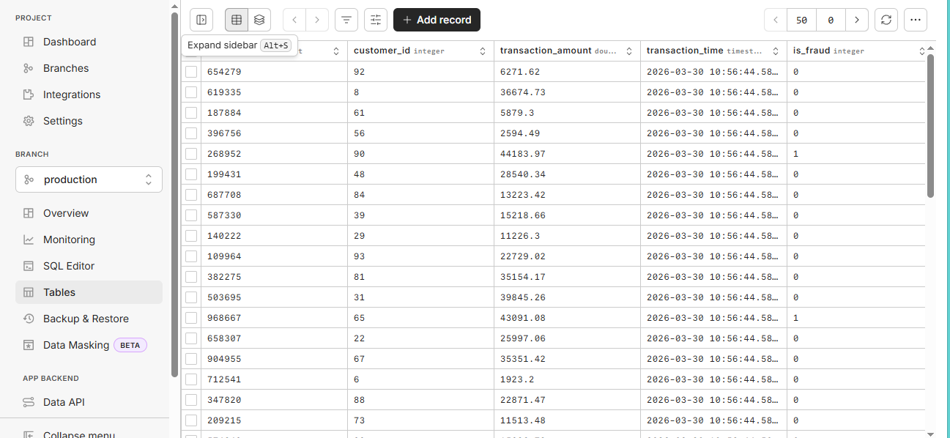
** While doing my feature engineering to train model I noticed the live data has a behavioral pattern that makes it hard to train model. >>> 100 customers in the database means each customer made just one transaction. >>> time of transaction is consistent with only current time making time difference impossible.
** So I went ahead to edit the generator and data entry script giving more flexibility to customer transactions on repeat and added 10 secs to 5 minutes differences in time and increased transactions count to 5000 for the 100 customers, So we have customers repeating and making different transactions. Now our DB live environment looks better
I built the model for our live environment using Random Forest Classifier, but noticed something strange, precision and recall as high as 100% which is an abnormal behavior and signaling either an entirely bad fraud detection logic or data leakage.
Engine Modification: Model was learning the rule used to generate fraud, not detecting fraud. So, I tuned some of the rules.
- Fraud signals contribute to a fraud score
- Score converted into probability
- Final label determined using randomness
Feature Engineering: Database stores raw transactional data. Feature engineering happens in Python pipeline. Here are the key features engineered for the model to be trained efficiently.
- time_diff
- transaction_hour
- txn_count
- avg_amount
- relative_amount
Model Selection: While learning with Kaggle static dataset, RFC model yielded the best result. Hence, I settled for that and after some modifications here and there the model now behaves exactly as expected and is learning patterns under uncertainty, which reflects real-world fraud systems. We will try out different thresholds and decide on the one to keep.
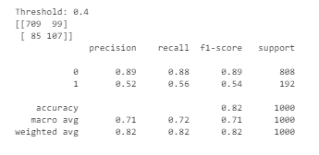
Current system state.
Synthetic Generator → Database → Feature Engineering → Model Training → Evaluation
At threshold 0.4 (Our best threshold result):
- Precision is 52%
- Recall is 56%
This is not exactly what I expected but it is the closest to a real fraud detection system as compared with other thresholds. Before deciding if to upgrade to a more advanced model, I will be adding some extra features to engine generator then see if that helps the model understand fraud patterns even better.
Generator Upgrade: I introduced new behavioral features to the generator.
- Location → Simulated customer transaction location
- Ip_address → Simulated network identity
- Device_id → Device used for transaction (mobile, web, tablet)
- Is_foreign_transaction → Flag for location inconsistency
- Device_change_flag → Flag for change in customer device

Customer Identity Simulation: Additional state tracking was implemented to simulate consistent user behavior.
- Customer_home_location → baseline location per user
- Customer_last_device → last used device
- Customer_last_ip → last known IP address

The generator and database pipeline were enhanced to include contextual and identity-based features such as location, IP address, and device usage. This upgrade improved the realism of simulated transactions and enabled more sophisticated fraud pattern detection

Now I will go ahead with engineering my features and train the current RFC model one more time and observe improvements

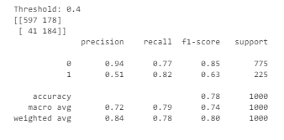
The upgraded model showed significant improvement after threshold tuning, and I settled with the threshold 0.4 which showed:
- Precision: 51%
- Recall: 82%

These features are like real live fraud detection model, other measures like OTP triggers can be integrated to pipe down false flagging and complement precision in a real world scenario.

Moving forward we will be building our scoring pipeline.

Scoring Pipeline: This pipeline loads the trained model and its decision threshold, then processes incoming transactions one at a time. Since real-time data does not naturally include historical context, key behavioral features such as transaction frequency and average spend were approximated using placeholder values. This allowed the model to operate even without full customer history.

Each transaction is transformed to match the exact structure used during training, including encoding categorical variables and aligning feature columns. The model then outputs a fraud probability, which is converted into a final prediction using the predefined threshold.

To validate the pipeline, a separate testing script was created. This script generates synthetic transactions using the simulation engine and immediately passes them through the scoring system. The output compares the model’s prediction with the generator’s fraud label, highlighting how the model interprets patterns independently from the rule-based simulation.

At this stage, the system achieved a key milestone:
a fully functional pipeline capable of taking raw transaction data and producing fraud predictions in real time.

This marks the transition from model development to live system simulation, setting the foundation for database integration and continuous fraud monitoring.

DB_scoring: After testing the scoring pipeline and the results were as expected I created another script that fully integrates the model into our DB. Now we have two new columns which return results based on the RFC model
- Model prediction: Fraud score (1 True, 0 False)
- Model probability: Probability score of how a transaction is likely to be fraud or not.
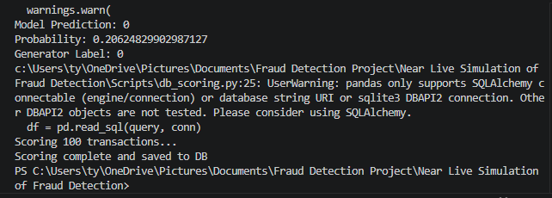

The system is now active and works in real time, but I will go ahead and do a little modification with the scoring pipelines to make sure it is not seeing only transactions but also seeing customer behavior and historic patterns to further enhance fraud scoring.

Everything has worked well so far. Today being 14th of April 2026, I have a working model and an active database where transactions go in and the fraudulent ones are flagged according to how or model predicts.

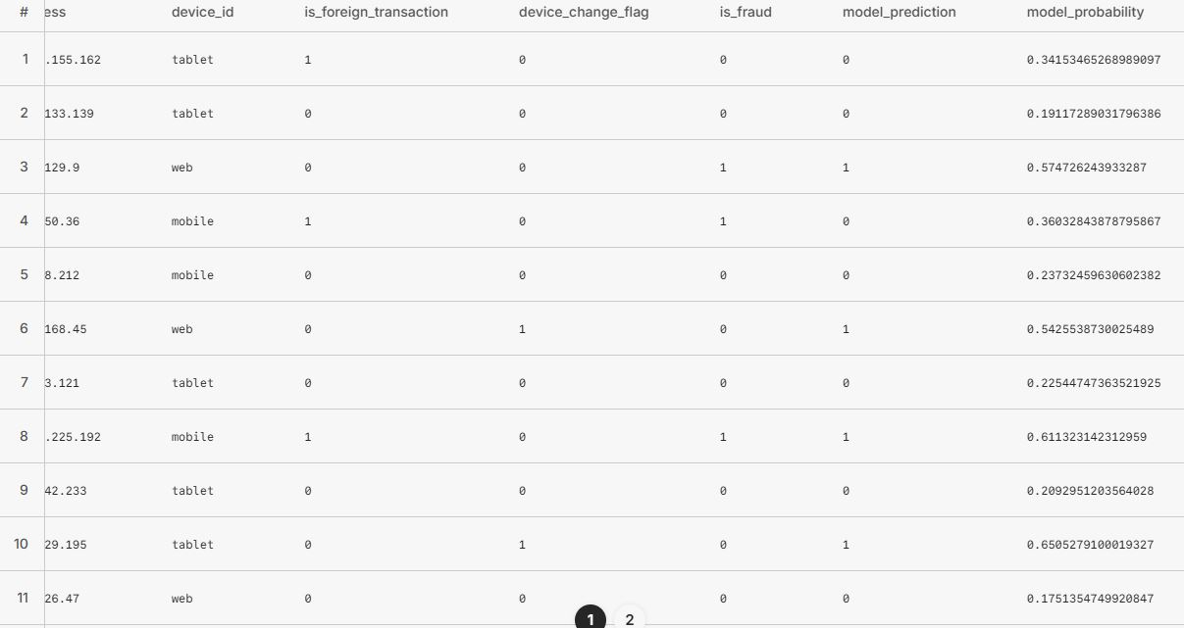

For a final touch I added two scripts:
Export_csv; This script reads the database and exports all rows or transactions that have been scored by the model to a csv file. The csv file updates but does not keep history of previously scored transactions as the database continues to update.
Master_pipeline; Single script that automates the entire pipeline of data entry, scoring and csv exports.
Now we have a database being monitored and scored by the fraud model, The csv allows users to interact with how much or how good the model has learnt to predict fraud patterns

Status:
- 1005 transactions scored
- 791
- 213
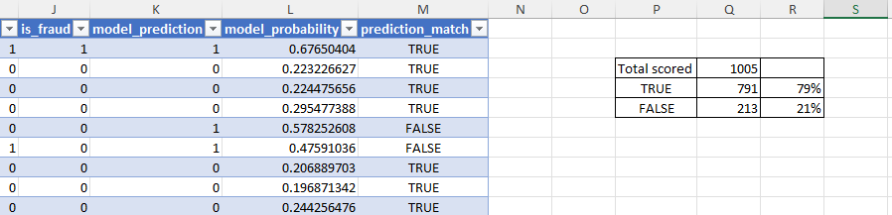

Today 10th May 2026, I did a few more runs on the master pipeline and built a stream lit App that updates scored transactions on the web and allows users the leverage of uploading their own fraud dataset to test my current model’s behavior.
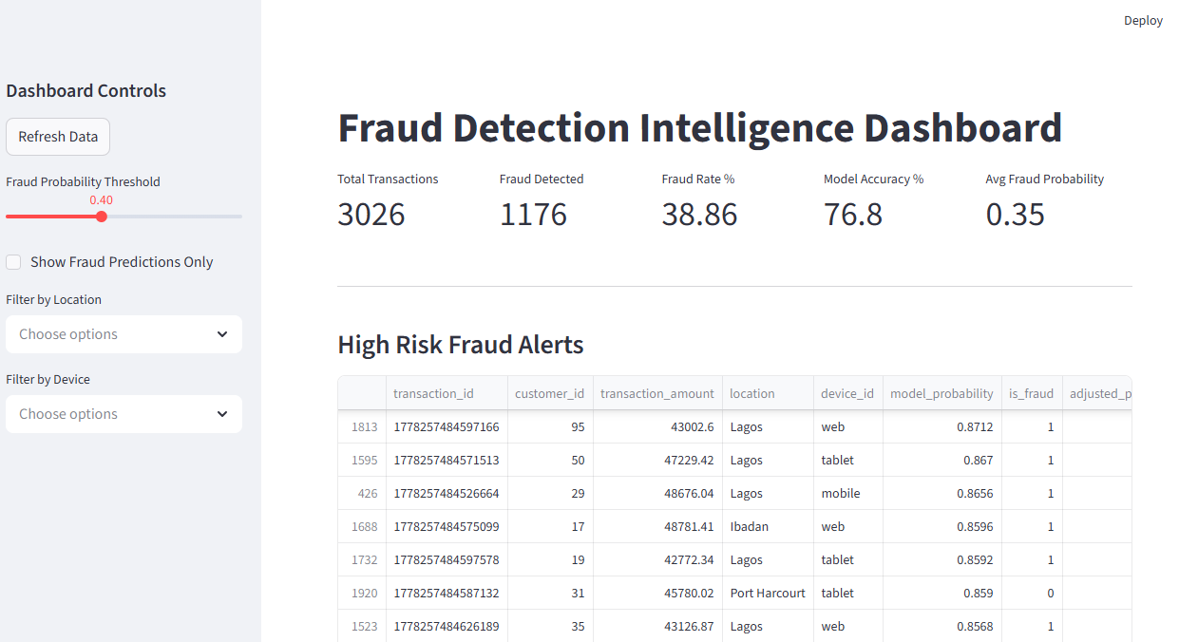

This is the final phase of the project before deployment. Excellent model behavior at 77% accuracy even as database grows. For future upgrade, I intend to give the model a better understanding of retraining itself thereby advancing in accuracy as it observes patterns from database growth.

